|  |
| --- |
| FlyAway.com  (Application Screen Shots) |

**Version History**

|  |  |
| --- | --- |
| Author | Bhagyashree palve |
| Purpose | Screenshots of the applications |
| Date | 16th Jan 2022 |
| Version | 1.0 |

**Contents**

1. Project Home Page ………………….……………………………………………………………………….. 3
2. Customer Pages ……………………………….………………………………………………………………… 3
3. Search Flight ………………………………………………………………………………………….. 3
4. Flight List ……………………………………………………………………………………………….. 3
5. Sign Up …………………………………………………………………………………………………. 4
6. Sign In ……………………………………………………………………………………………………. 4
7. Payment and Booking ……………………………………………………………………………. 5
8. Order History …………………………………………………………………………….. ………… 5
9. Admin Pages ….………………………………………………………………………………………. ………….. 6
10. Admin Login ………………………………………………………………………………………………. 6
11. Admin Welcome ………………………………………………………………………………………… 6
12. Employee Services ……………………………………………………………………………………. 7
13. Employee Lists …………………………………………………………………………………………… 7
14. Flight Services …………………………………………………………………………………………… 8

T=

1. **Project Home Page**

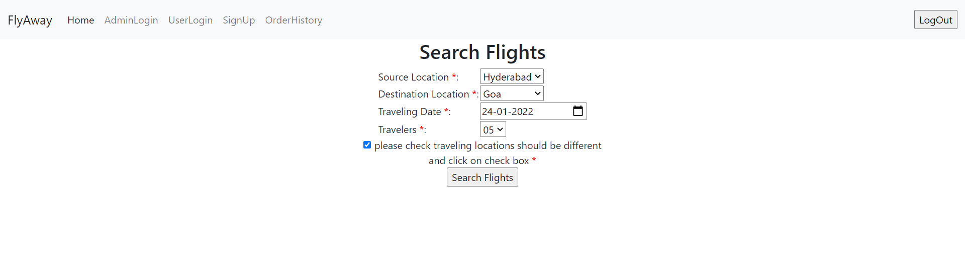

1. **Customer Pages**
2. **Search Flight**



1. **Flight List**

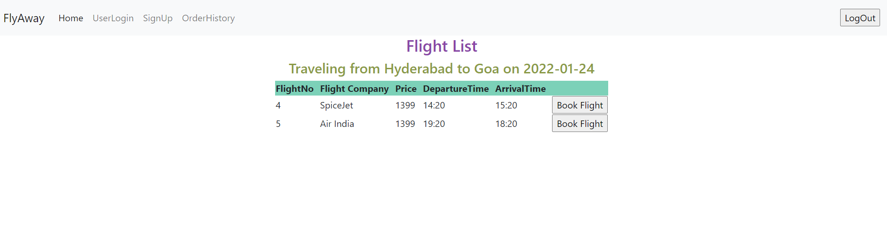

1. **Sign Up**

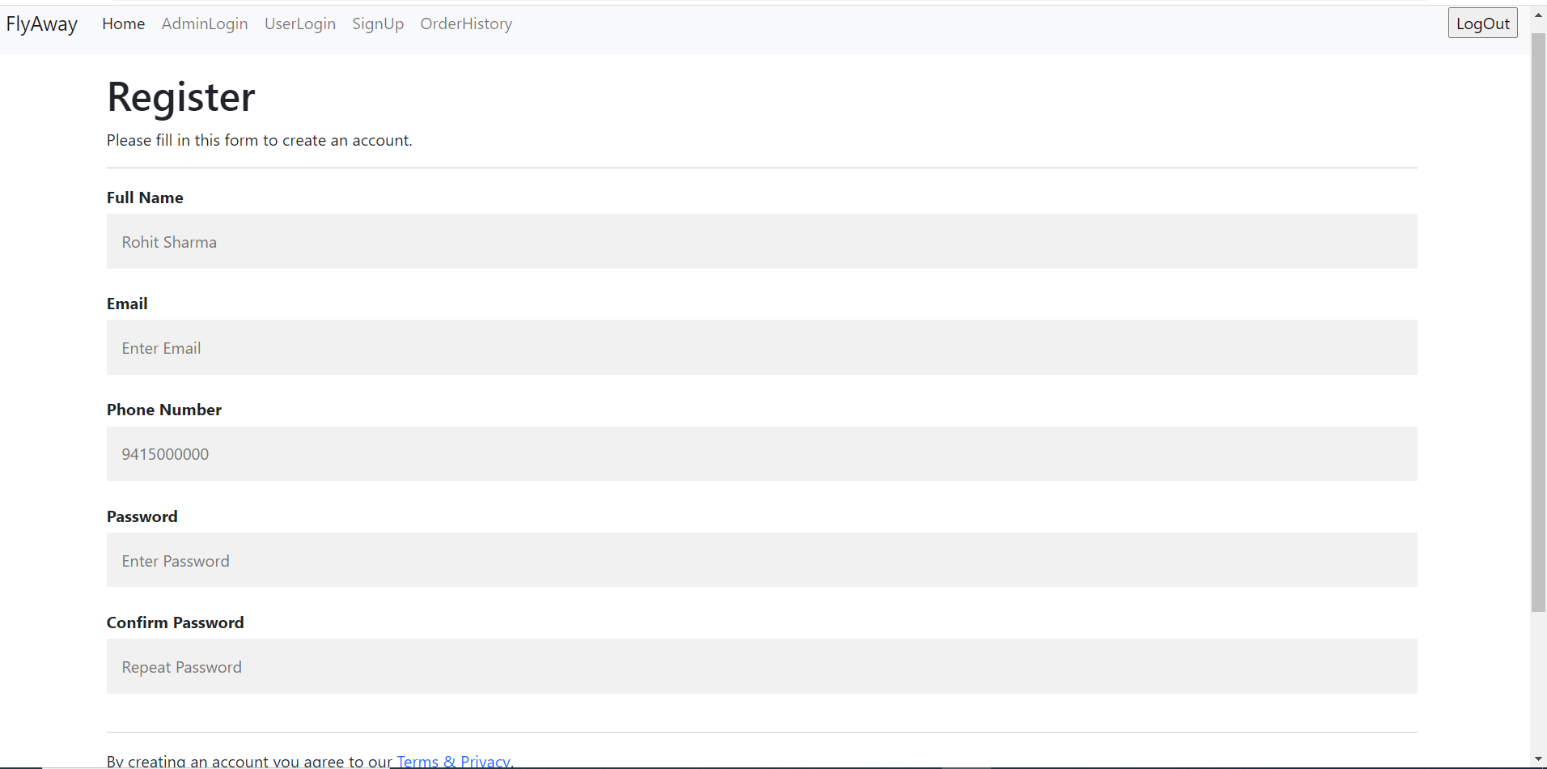

1. **Sign in**

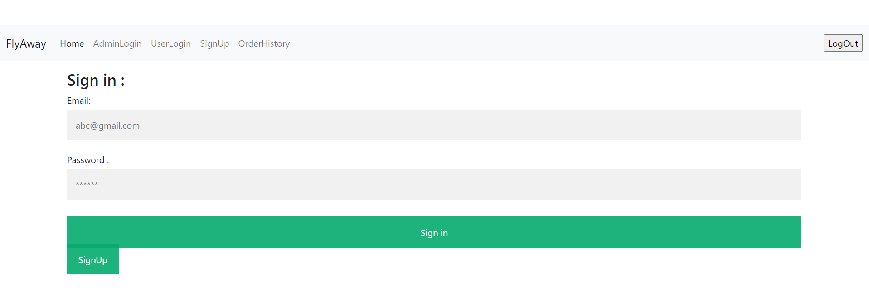

1. **Payment and Booking**

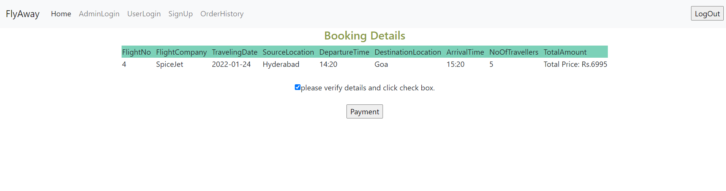

1. **Order History**

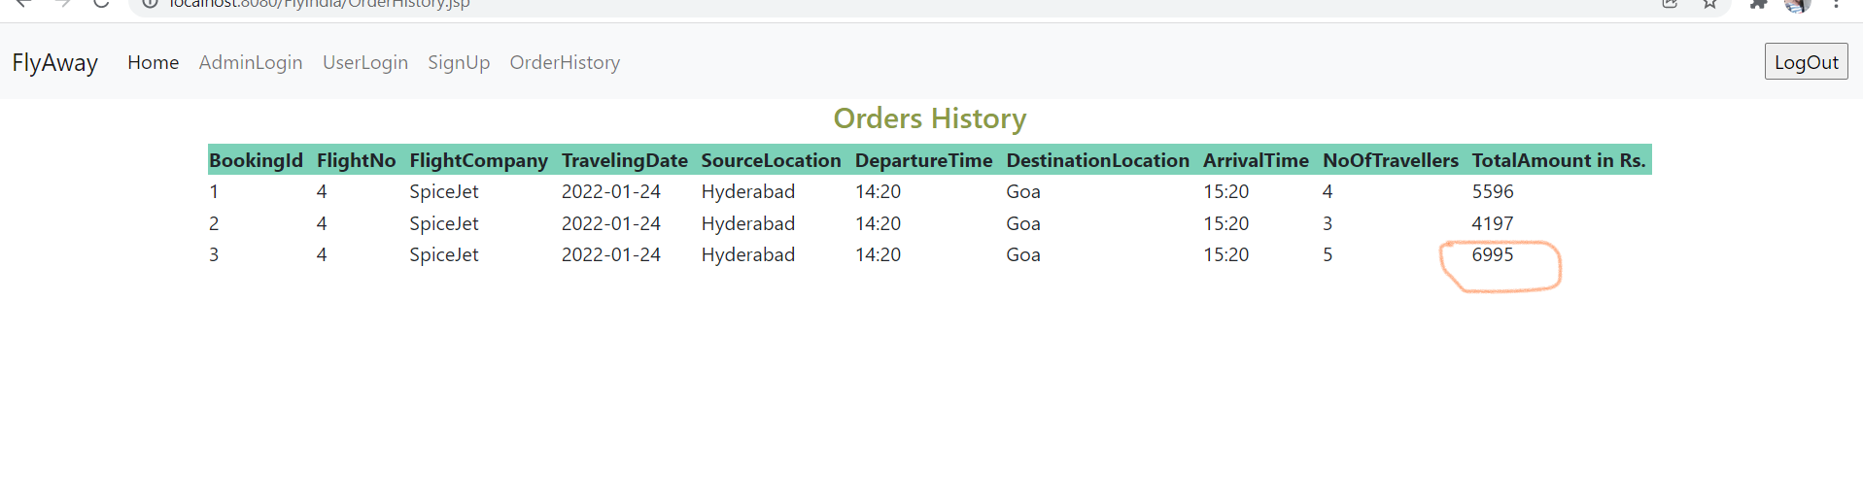

1. **Admin Pages**
2. **Admin login**

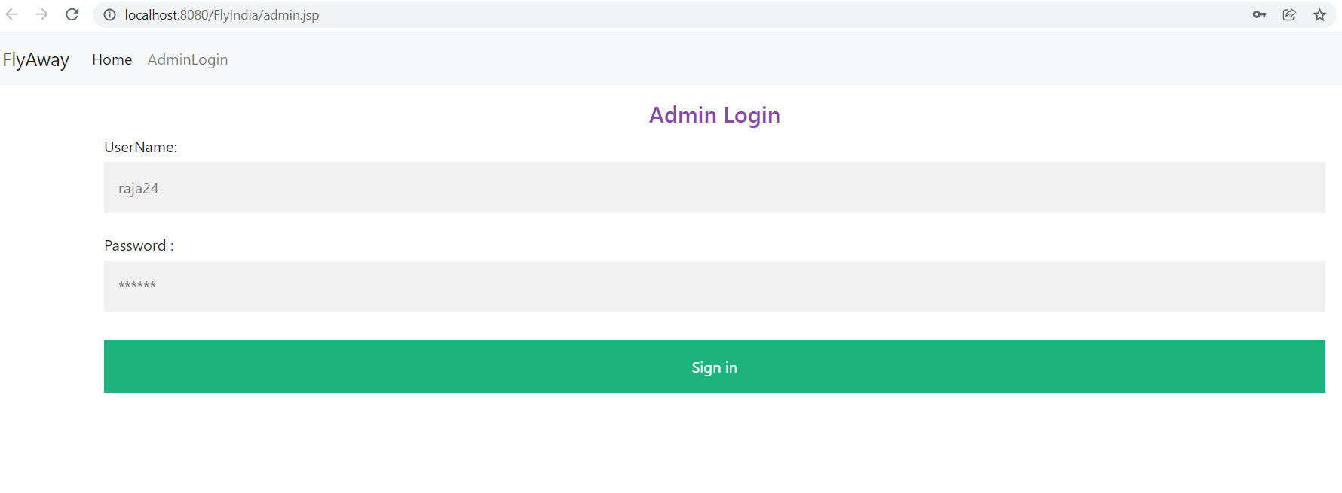

1. **Admin Welcome Page**

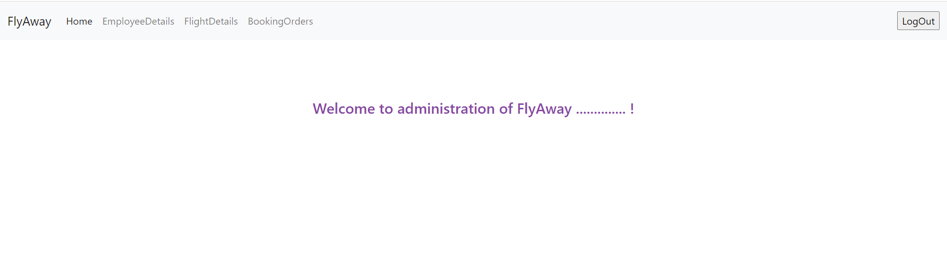

1. **Employee Services**

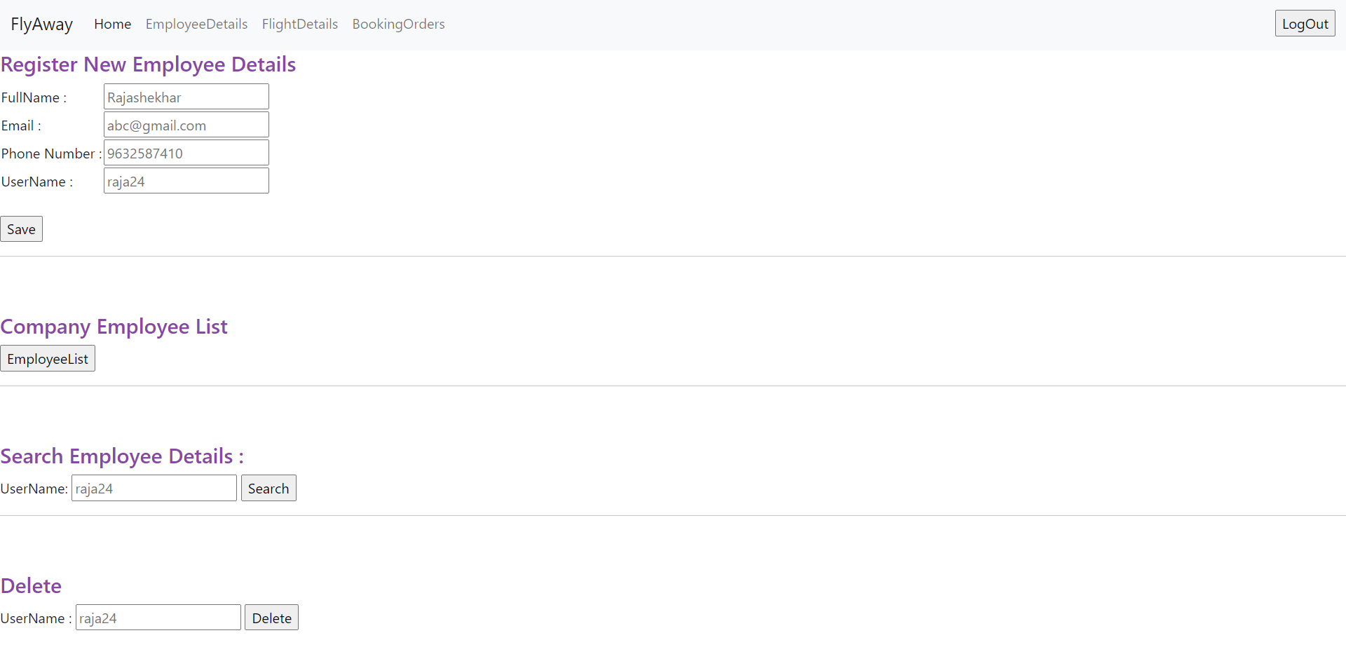

1. **Employee List**

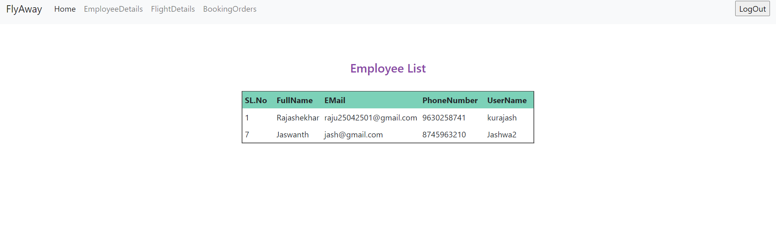

1. **Flights Services**

